CLASSIC BRICK BREAKER GAME

🎮 Brick Breaker Game - Defend the Kingdom

A modern take on the classic brick breaker game with enhanced features including power-ups, particle effects, sound effects, and progressive difficulty system.

🌟 Overview
Brick Breaker is a web-based arcade game where players control a paddle to bounce a ball and destroy bricks to defend their kingdom from invading magical orbs. The game features multiple levels, various power-ups, and an engaging scoring system.

🎯 Game Narrative
The kingdom's defensive walls (bricks) are under siege from magical invading orbs. As the royal defender, you must use your enchanted paddle to redirect these orbs back at the walls, protecting the kingdom while earning glory and high scores!

Features

Core Gameplay
- ⚔️ Smooth paddle controls with keyboard input (Arrow Keys / A,D)
- 🎯 Precise ball physics with angle-based bouncing
- 🧱 Multi-hit bricks that require multiple strikes to destroy
- 💥 Particle effects when bricks break
- 🔊 Dynamic sound effects for all game events

Power-Up System
- 🟢 Wide Paddle - Extends paddle width for 10 seconds
- 🔴 Extra Life - Grants an additional life
- 🟡 Slow Ball - Reduces ball speed for 8 seconds
- 🔵 Multi-Ball - Spawns additional balls

Progression & Difficulty
- 📈 Progressive difficulty - Ball speed increases with each level
- 🎚️ Dynamic brick patterns across different levels
- 🏆 High score tracking with persistent storage
- ⭐ 5-tier scoring system based on brick colors

User Interface
- 🎨 Modern gradient design with glowing effects
- 📊 Real-time HUD displaying Lives, Score, Level, and Remaining Bricks
- ⏸️ Pause functionality (Press P or ESC)
- 📖 Comprehensive instructions menu
- 🏠 Polished start/game over screens

🚀 How to Play

Installation & Setup
- Clone the repository:
git clone https://github.com/yourusername/brick-breaker-game.git
cd brick-breaker-game
- Open the game:
  - Simply open index.html in any modern web browser
  - No installation or dependencies required!
- Play online:
  - Visit: https://github.com/engracheal/brick-breaker-game/tree/main

Controls
Key | Action
← → or A D | Move paddle left/right
SPACE or ENTER | Launch ball
P or ESC | Pause/Resume game
🔊 Button | Toggle sound on/off

Game Rules
- Objective: Destroy all bricks to advance to the next level
- Lives: You start with 3 lives. Lose a life when the ball falls below the paddle
- Winning: Clear all bricks across all levels
- Losing: Run out of lives before clearing all bricks

Scoring System
Brick Color | Points | Position
🔴 Red | 10 points | Top row
🟠 Orange | 8 points | Second row
🟡 Yellow | 6 points | Middle row
🟢 Green | 4 points | Fourth row
🔵 Blue | 2 points | Bottom row

🏗️ Technical Architecture

Technology Stack
- HTML5 Canvas - For rendering game graphics
- Vanilla JavaScript - Game logic and mechanics
- Web Audio API - Dynamic sound generation
- CSS3 - Modern UI styling with animations

Class Architecture
The game follows Object-Oriented Programming principles:

Core Classes
Game - Main game controller
- Manages game state (menu, playing, paused, gameover)
- Handles game loop and rendering
- Coordinates all game objects
Paddle - Player-controlled paddle
- Movement logic with boundary detection
- Power-up effects (width extension)
- Collision detection with ball
Ball - Game ball with physics
- Movement with velocity vectors
- Collision detection (walls, paddle, bricks)
- Speed progression system
Brick - Destructible obstacles
- Multi-hit capability
- Color-based scoring
- Visibility state management
PowerUp - Collectible bonuses
- 4 different types with unique effects
- Falling animation
- Collision detection with paddle
Particle - Visual effects system
- Explosion effects when bricks break
- Physics-based movement
- Life cycle management
SoundManager - Audio system
- Web Audio API integration
- Event-based sound triggers
- Mute/unmute functionality

🎮 Game Mechanics

Collision Detection
Ball-Paddle Collision:
- Detects ball contact with paddle surface
- Calculates bounce angle based on hit position
- Applies velocity changes for realistic physics
Ball-Brick Collision:
- Uses AABB (Axis-Aligned Bounding Box) detection
- Reverses ball direction on contact
- Handles multi-hit brick degradation
Power-up Collection:
- Checks overlap between falling power-ups and paddle
- Triggers power-up effect on collection
- Removes collected power-ups from game

Difficulty Progression
Level | Ball Speed | Multi-Hit Bricks | Power-up Chance
1 | 4.0 | 0% | 20%
2 | 4.3 | 0% | 20%
3+ | 4.6+ | 30% | 20%

Risk Management
Player must navigate:
- ⚡ Increasing ball speed as levels progress
- 🧱 Bricks requiring multiple hits (Level 3+)
- ⏰ Limited reaction time at higher speeds
- 💀 Limited lives (3) to complete all levels
Balancing mechanisms:
- 🎁 Power-ups provide strategic advantages
- 🎯 Paddle angle affects ball direction for control
- 📊 Progressive difficulty curve maintains engagement

Main Menu
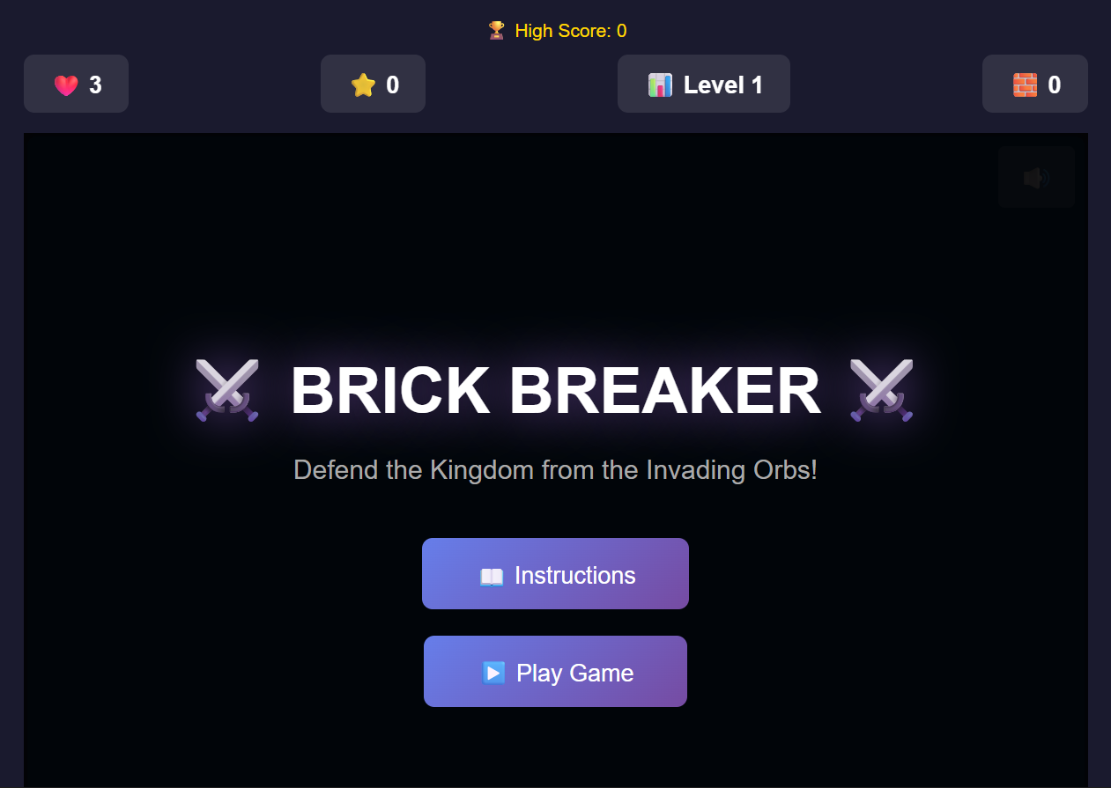

Gameplay

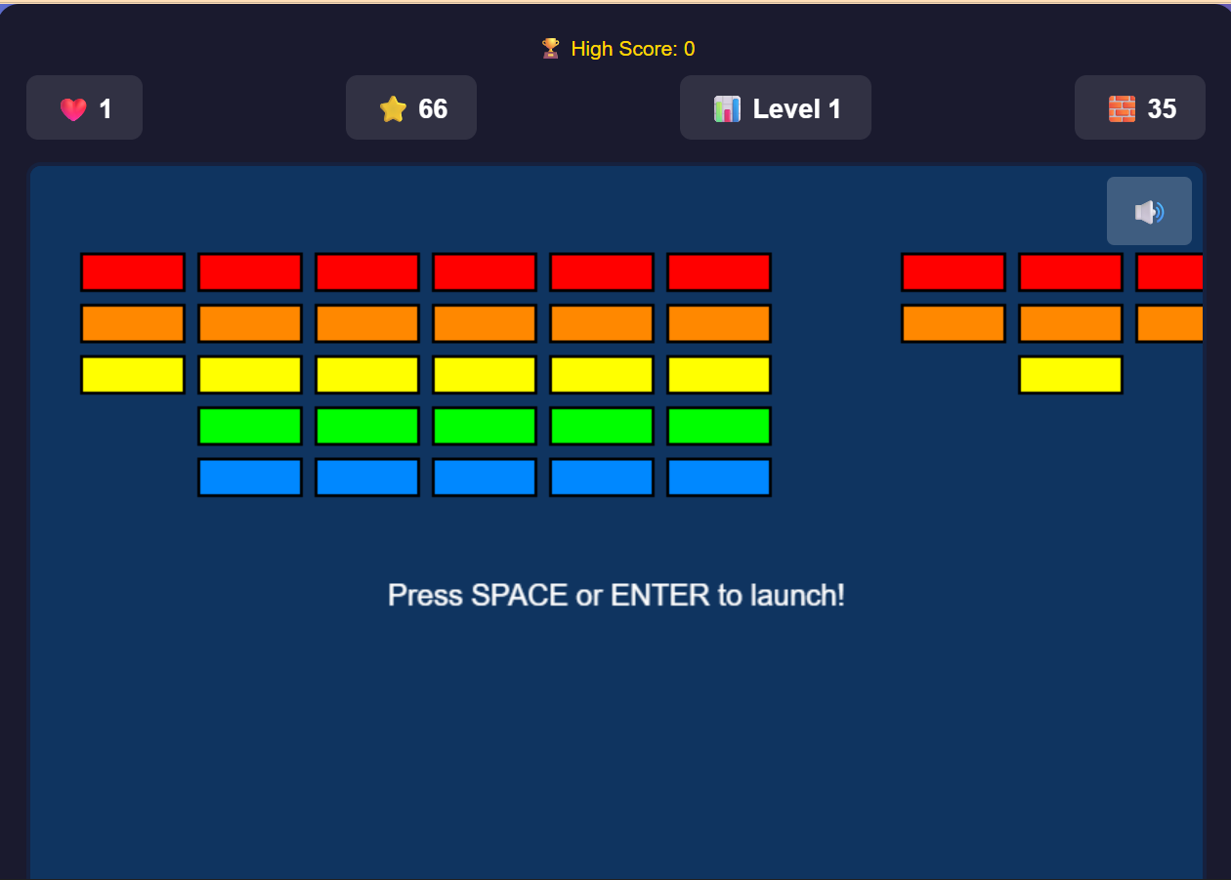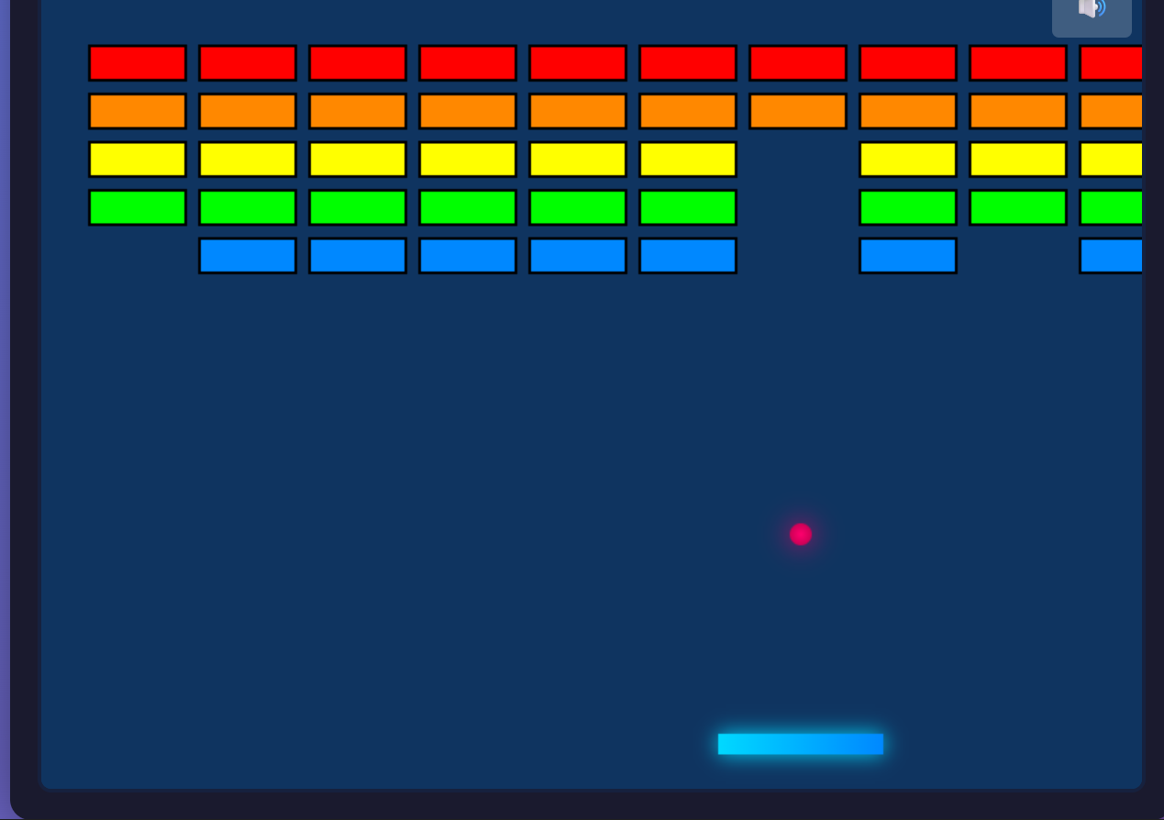

Power-ups
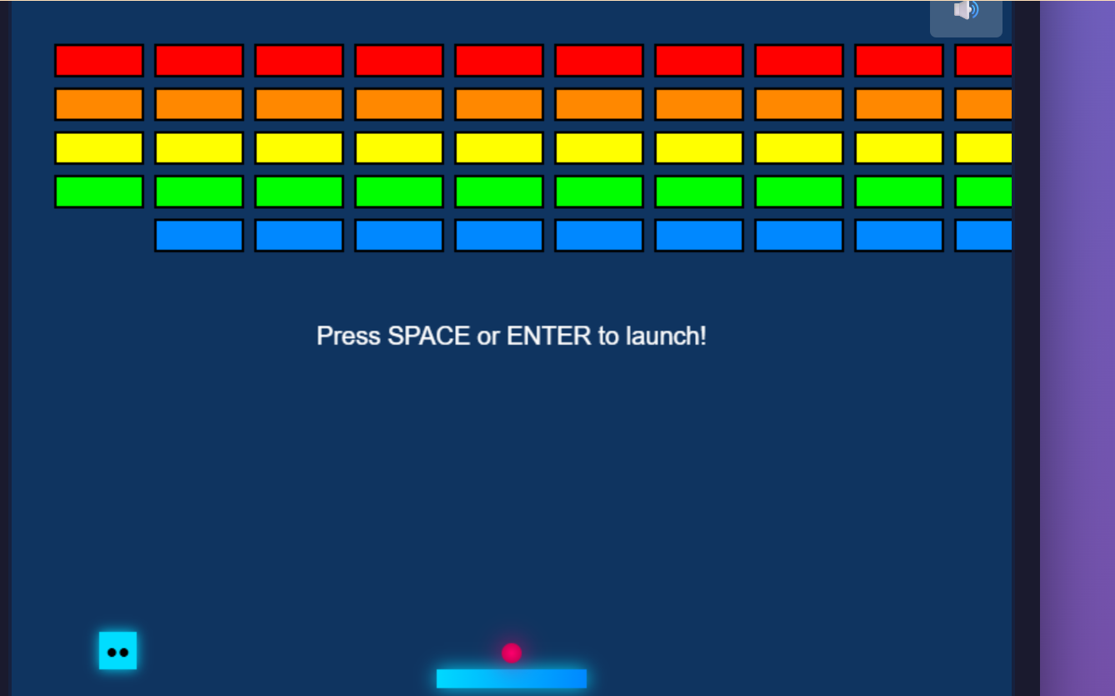

Game Over
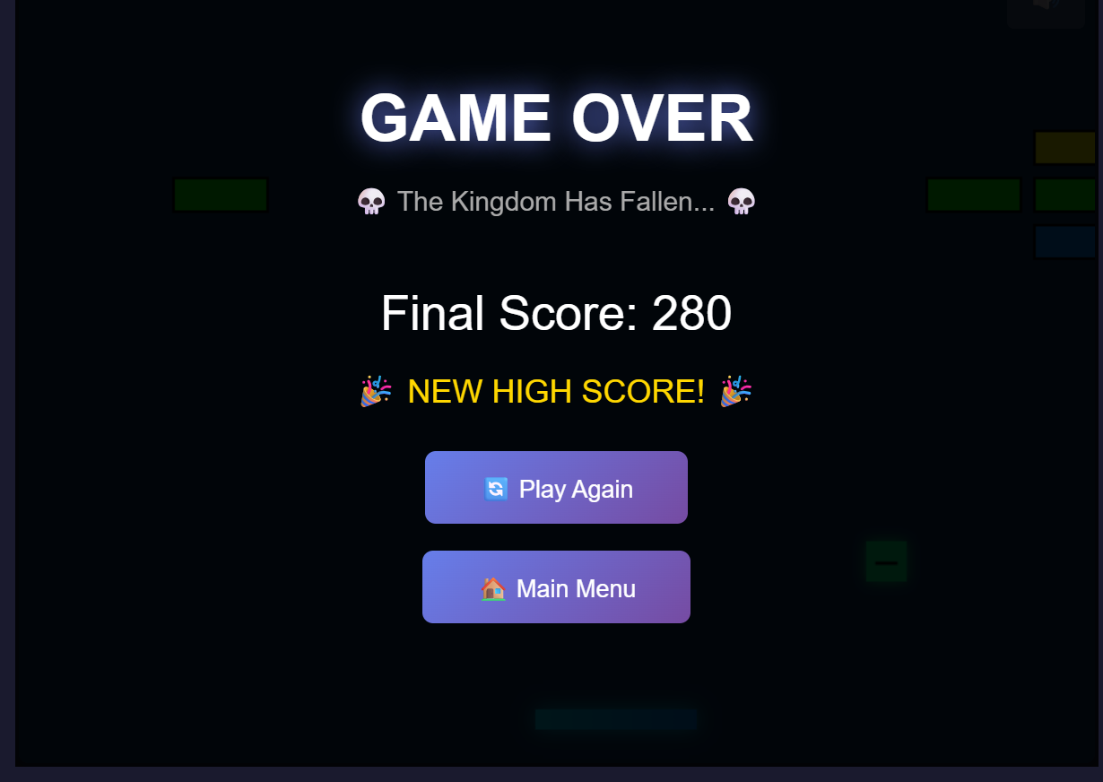

🧪 Testing & Quality Assurance

Tested Scenarios
✅ Mechanics Testing:
- Paddle movement and boundary detection
- Ball physics and collision accuracy
- Brick destruction and scoring
- Power-up spawning and effects
✅ UI/UX Testing:
- Menu navigation flow
- HUD updates in real-time
- Pause/resume functionality
- Game state transitions
✅ Performance Testing:
- Smooth 60 FPS rendering
- Particle system optimization
- Memory leak prevention
- Browser compatibility
✅ Edge Cases:
- Multiple balls on screen
- Rapid brick destruction
- Power-up stacking
- Level transitions

Browser Compatibility
Browser | Version | Status
Chrome | 90+ | ✅ Fully Supported
Firefox | 88+ | ✅ Fully Supported
Safari | 14+ | ✅ Fully Supported
Edge | 90+ | ✅ Fully Supported

🚧 Known Limitations & Future Enhancements

Current Limitations
- Single-player only (no multiplayer mode)
- Fixed brick patterns (no level editor)
- Web Audio API requires user interaction to enable

Planned Features
- 🎨 Level Editor - Create custom brick patterns
- 🏅 Leaderboard System - Global high score tracking
- 🎵 Background Music - Ambient soundtrack
- 📱 Mobile Support - Touch controls for mobile devices
- 🌍 More Levels - Extended campaign with boss levels
- 🎁 More Power-ups - Shield, fireball, explosive ball
- 💾 Save System - Resume progress across sessions

📚 Resources & Documentation

Project Links
- 🎥 Video Demo
- 🌐 Play Online
- 💻 Source Code

Development Resources
- HTML5 Canvas API
- Web Audio API
- Game Development Patterns

📞 Contact & Support
For questions or feedback about this project:
- GitHub Issues: Create an issue
- Email: ampumuzarecheal152@gmail.com

🎉Enjoy the Game!
Defend the kingdom, break those bricks, and set a new high score!

Quick Start Commands
# Clone the repository
git clone https://github.com/yourusername/brick-breaker-game.git

# Navigate to directory
cd brick-breaker-game

# Open in browser (Mac)
open index.html

# Open in browser (Windows)
start index.html

# Open in browser (Linux)
xdg-open index.html

